Table of Contents

I. Purpose 1

II. Scope 1

III. Responsibilities 1

IV. Definitions 2

V. References 2

VI. System Requirements and Equipment 2

VII. Excel Tabs and Buttons 2

VIII. Procedure 6

IX. Attachments 7

X. Revision History 7

XI. Approvals 7

1. Purpose

This document provides instructions for the use of SCS IT.04.01 QACAR, an Excel workbook file that is designed to facilitate the process of biodistribution studies by analyzing qPCR data. SCS IT.04.01 QACAR consists of several Excel tabs, VBA macro functions and a Python program. This document will describe the procedure for using these sheets, macros, and programs.

1. Scope

This document provides detailed instructions for using SCS IT.04.01 QACAR.

1. Responsibilities
2. It is the responsibility of the Software Developer to install the software and ensure the front-end programs and back-end database perform as specified in the user requirements and design specifications.
3. It is the responsibility of the Employee/Study Director to ensure that they are adequately trained before using SCS IT.04.01 QACAR.
4. It is the responsibility of the Study Director to ensure the results are accurate before finishing a biodistribution study.
5. The Quality Unit is responsible for monitoring compliance with this SOP.
6. Definitions
7. **SCS 19** – an Excel workbook file with multiple sheet tabs that is designed to help conducting biodistribution studies and analyzing qPCR data.
8. **Python –** A programming language that will be used to create this program. Python is an interpreted high-level general-purpose programming language. Its design philosophy emphasizes code readability with its use of significant indentation. Its language constructs as well as its object-oriented approach aim to help programmers write clear, logical code for small and large-scale projects.
9. **qPCR** – Quantitative Polymerase Chain Reaction. A PCR method used to quantify the number of copies or relative number of copies of a target sequence.
10. **SCS IT.04.01 QACAR** – An excel workbook file containing QACAR (qPCR Auto Calc and Report), a software pipeline composed of a macro enabled spreadsheet, VBS script and the QACAR program, which consists of Python code used for calculating and reporting qPCR data.
11. References
12. 21 CFR Part 11, Electronic Records; Electronic Signatures - Scope and Application
13. 21 CFR Part 58
14. SOP LO QPCR 08 QPCR Absolute Quantification for a Biodistribution Study
15. SCS 19 Biodistribution Study
16. System Requirements and Equipment
17. PC with Windows OS
18. Python 3.9.6
19. Microsoft Excel 2019
20. Pandas 1.3.1
21. Datetime 4.3
22. Openpyxl 3.0.7
23. Teracopy 3.9

1. Excel Tabs and Buttons
2. QACAR CONTROLS TAB

This sheet allows users to manage the behavior of the QACAR program, which analyzes qPCR data. The buttons on this sheet allow the user to input project criteria, select a folder of qPCR data to analyze, exclude files from the QACAR program’s analysis and also initiate the QACAR program.

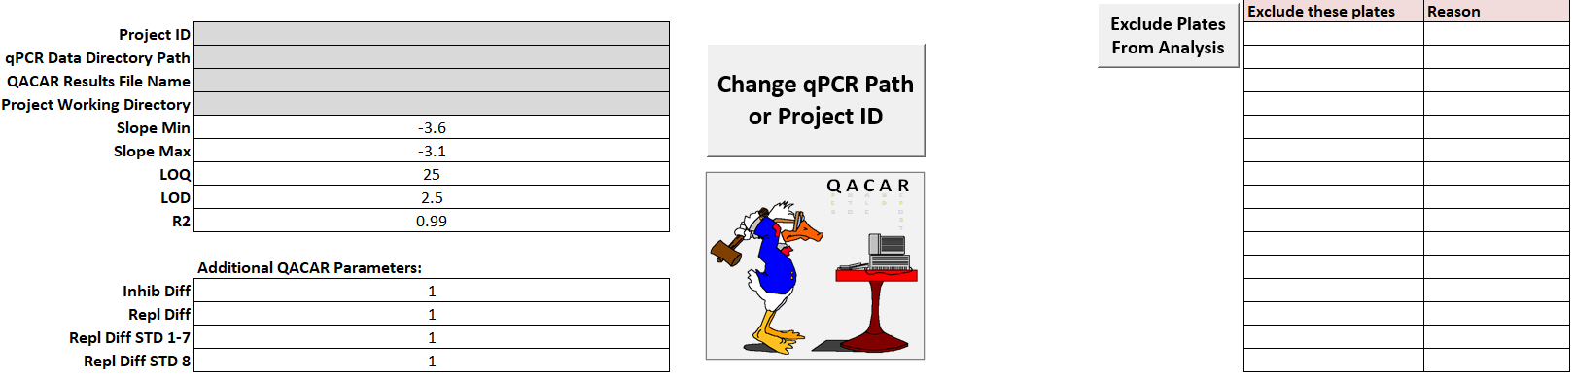

1. Button: ‘Change qPCR Path or Project ID’

The user can click this button to assign the QACAR program parameters highlighted gray in the above figure. This function will also activate upon opening the SCS IT 04.01 QACAR workbook if the gray cells are not already filled in. Upon activating, this function will prompt the user for a Project ID and then open a folder select dialog box so the user can select a qPCR data folder for the QACAR program to analyze.

After these two inputs, the function will fill in the other two gray highlighted parameters automatically. If the user inputs a Project ID shorter than 6 characters, the function will report an error and stop.

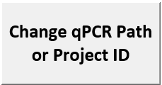

1. Button: ‘Exclude Plates From Analysis’

The QACAR program is designed to analyze an entire folder of qPCR data files. So, this button can be used to exclude specific files from the analysis.

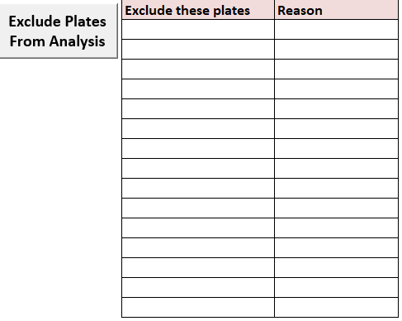

1. Button: ‘QACAR’



This button launches QACAR, which stands for “qPCR Auto Calc And Report”, a VBA/Python software pipeline designed to process and analyze raw qPCR data. This program relies on the following information from the QACAR Controls tab to be filled out correctly:

1. Project_ID: should reflect the biodistribution project’s ID.
2. qPCR Data Directory Path: should reflect a folder containing the qPCR data to be analyzed.
3. QACAR Results File Name: will be automatically filled after using the ‘Change qPCR Path or Project ID’ function.
4. Project Working Directory: will be automatically filled after using the ‘Change qPCR Path or Project ID’ function.
5. Exclude Plates: a button used to select qPCR data to exclude from analysis (if needed)

The following must be filled in: Slope Min, Slope Max, LOQ, LOD, R2, Inhib Diff, Repl Diff, Repl Diff STD1-7, Repl Diff STD8

1. Form10_Raw Data Tab

This sheet contains printouts of the raw qPCR data along with calculations tables to test some qPCR acceptance criterion. It also has a function that allows users to transfer the report into SCS19.

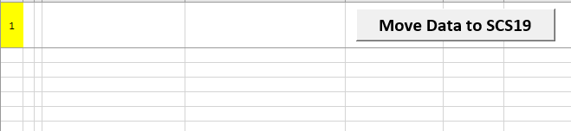

1. Button: ‘Move Data to SCS19’

Once the Form10_Raw Data sheet contains some results from the QACAR program, the user can use this button to transfer those results into an SCS19 workbook. This function requires some results to be present and a valid SCS19 file to transfer the results to.

1. Root Path Settings Tab

This sheet allows users to modify some of the paths that the QACAR program/functions use by default.

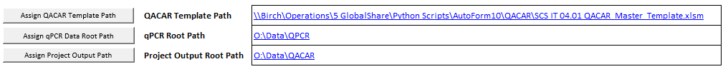

1. Button: ‘Assign QACAR Template Path’

This password protected

1. Form12_Plate Report Tab

This sheet presents a summary of whether each qPCR plate/sample passed or failed. This sheet is an output of the QACAR pipeline.

1. Form13_ReRun Samples Tab

This sheet presents a summary of all of the qPCR plates and samples that failed and why. It also summarizes which plates/samples were re run. This sheet is an output of the QACAR pipeline.

1. Form14_AC Report Tab

This sheet summarizes some calculations on the assay controls of passing plates. This sheet is an output of the QACAR pipeline.

1. Form15_Y Intercept Report Tab

This sheet summarizes Y Intercept and STD curve values to provide a way of detecting trends or shifts in those values within the entire study. This sheet is an output of the QACAR pipeline.

1. Procedure
2. If using SCS IT.04.01 QACAR to analyze qPCR data for a biodistribution project, a user can start by setting parameters for the program in the QACAR Controls. The ‘Change qPCR Path or Project ID’ function can be used to update the gray highlighted parameters. The other parameters (colored white) can be clicked on and typed in.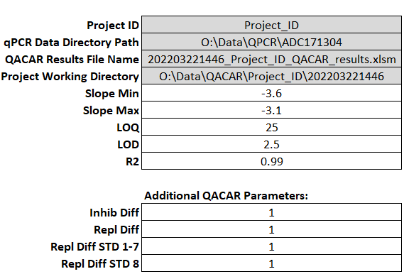
3. Next, the user will use the ‘Exclude Plates From Analysis’ button if they wish to exclude a file from the analysis of the qPCR raw data folder. A valid file must be selected and an exclusion reason must be provided.
4. Next, the user can click the QACAR button to run the QACAR program, which will analyze the qPCR data.



1. If the QACAR program encounters an error, it may be necessary to modify the parameters in the Root Path Settings tab.
2. Next, the user can find the resulting files in \\birch\operations\data\QACAR\{Project_ID}\{timestamp} and observe the results in Form10_Raw Data, Form12_Plate Report, Form13_Re Run Samples, Form14_AC Report and Form15_Y Intercept Report. {timestamp} reflects the time of the program run and follows this convention (YYYY MM DD HH mm).
3. If desired, the user can use the ‘Move Data to SCS19’ button to transfer the Form10_Raw Data report into SCS19, which when transferred, should automatically populate SCS19’s Form11 report with healthy sample information.
4. Attachments
5. N/A
6. Revision History

|  |  |  |
| --- | --- | --- |
| Version | Effective Date | Changes |
| 01 | XX Oct 2021 | Original SOP CRN# XX-XXX |
|  |  |  |
|  |  |  |

1. Approvals

|  |  |  |  |
| --- | --- | --- | --- |
| Name | Title | Signature | Date |
| Xuening Huang | CEO |  |  |
| David Wall | VP of Quality |  |  |